MODULE 3
USING AUDIO AND VIDEO
Capturing digital and analog video - importing audio - Working with Clips - Turning Your Clips into a Movie - Fixing Color and Light Issues - Using Transitions and Titles - Working with Audio

Digital Video:
Digital video is a representation of moving visual images using discrete binary data.In simpler terms, it's video that's stored, transmitted, and processed as a series of numbers. Each frame of the video is represented by a sequence of binary digits (0s and 1s), allowing for precise reproduction and manipulation of the visual content.
Digital video is commonly used in modern technology, such as DVDs, streaming services, and video files on computers.

Analog Video:
Analog video, on the other hand, is the representation of moving visual images using continuous electrical signals. Instead of using discrete binary data like digital video, analog video records and processes visual information as continuous waveforms.
This type of video technology was prevalent before the widespread adoption of digital formats and is still found in older devices like VHS tapes and analog television broadcasts.
Analog video signals are susceptible to degradation and interference over long distances, and they typically offer lower resolution compared to digital video.

DIFFERENTIATION BETWEEN ANALOG AND DIGITAL:
Representation of Visual Information:
Analog Video: Represents visual information using continuous waveforms. The signal fluctuates smoothly, resembling the original image.
Digital Video: Represents visual information using discrete binary data. The image is broken down into a series of binary numbers, which can be stored and transmitted efficiently.

Signal Transmission:
Analog Video: Transmits signals through continuous waveforms over cables or airwaves. Susceptible to degradation and interference over long distances.
Digital Video: Transmits signals as discrete packets of data. Less susceptible to degradation and interference, often allowing for longer-distance transmission without loss of quality.

Quality and Resolution:
Analog Video: Typically lower resolution compared to digital video. Limited by the capabilities of the analog technology.
Digital Video: Offers higher resolution and quality due to the ability to represent images precisely using binary data. Can support various resolutions, including standard definition (SD), high definition (HD), and ultra-high definition (UHD).

Storage and Editing:
Analog Video: Requires specialized equipment for recording and editing. Editing involves physically cutting and splicing tapes or using analog editing equipment.

Digital Video: Can be easily stored, edited, and manipulated using digital technology. Editing is done using software on computers, allowing for non-destructive editing, special effects, and easy duplication.

Compression and Efficiency:
Analog Video: Does not employ compression techniques. Each frame is transmitted or recorded in its entirety.
Digital Video: Often utilizes compression algorithms to reduce file sizes while maintaining visual quality. Allows for efficient storage, transmission, and streaming of video content.

CAPTURING DIGITAL VIDEO

Equipment Needed:
Digital Camera/Camcorder: A device capable of capturing digital video. This can include DSLRs, dedicated camcorders, smartphones, or action cameras.
Memory Card: Used to store the digital video files captured by the camera. Power Source: Ensures the camera remains powered during the recording process.
Setting Up the Camera:Turn on the digital camera/camcorder.Adjust settings such as resolution, frame rate, exposure, focus, and white balance depending on the desired quality and look of the video.

Framing the Shot:
Use the camera's viewfinder or LCD screen to frame the shot. Consider factors such as composition, lighting, and camera angle to capture the desired footage.

Recording:
Press the record button on the camera to start recording. Ensure that the camera is stable to avoid shaky footage. Monitor the recording through the camera's display screen to ensure the desired content is being captured.

Capturing Audio (Optional):
Some digital cameras/camcorders have built-in microphones for capturing audio. Alternatively, external microphones can be connected to capture higher-quality audio.
Consider factors such as ambient noise and microphone placement to ensure clear audio recording.

Stopping Recording:
Press the stop button on the camera to stop recording once the desired footage has been captured.

Reviewing Footage:
Playback the recorded footage on the camera's display screen to review the quality and content. Ensure that the captured video meets the desired standards before proceeding further.

Transferring Video Files:
Remove the memory card from the camera and insert it into a card reader connected to a computer.
Use file transfer software to copy the digital video files from the memory card to the computer's hard drive for further editing or sharing.

Storage and Backup:
Store the captured digital video files in a secure location on the computer or external storage devices. Consider creating backups of the video files to prevent loss in case of hardware failure or accidental deletion.

CAPTURING ANALOG VIDEO

Equipment Needed:
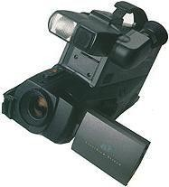
Analog Video Camera: A device capable of capturing analog video. This can include analog camcorders, VHS camcorders, or analog surveillance cameras.

Recording Media: Analog video is typically recorded onto physical media such as VHS tapes, Hi8 tapes, or analog video cassette tapes.
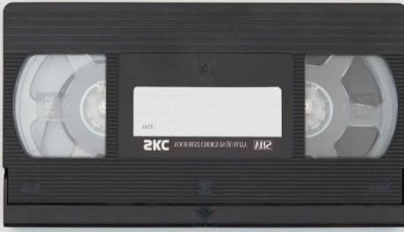

Power Source: Ensures the camera remains powered during the recording process.
Optional: Microphones or audio recording equipment for capturing audio.

Setting Up the Camera:
Turn on the analog video camera.
Adjust settings such as focus, exposure, and white balance depending on the desired quality and look of the video. Some analog cameras may have limited manual controls.

Loading the Recording Media:
Insert a blank VHS tape or other analog recording media into the camera or recording device. Ensure that the recording media is properly loaded and secured in the device.

Framing the Shot:
Use the camera's viewfinder or LCD screen (if available) to frame the shot. Consider factors such as composition, lighting, and camera angle to capture the desired footage.

Recording:
Press the record button on the camera to start recording. Ensure that the camera is stable to avoid shaky footage.
Monitor the recording through the camera's viewfinder or LCD screen to ensure the desired content is being captured.

Capturing Audio (Optional):
Some analog cameras have built-in microphones for capturing audio. Alternatively, external microphones can be connected to capture higher-quality audio.
Consider factors such as ambient noise and microphone placement to ensure clear audio recording.

Stopping Recording:
Press the stop button on the camera to stop recording once the desired footage has been captured.

Rewinding and Reviewing Footage:
If using tapes, rewind the tape to review the recorded footage on the camera's viewfinder or playback screen. Ensure that the captured video meets the desired standards before proceeding further.

Storage and Backup:
Store the captured analog video tapes in a cool, dry place to prevent degradation over time.
Consider creating digital backups of analog video footage to prevent loss in case of tape deterioration or damage.
By following these steps, you can effectively capture analog video footage using an analog video camera or camcorder. Adjustments and additional steps may be required depending on the specific camera model and recording conditions.

IMPORTING AUDIO:

Selecting Audio Source:
Determine the source of the audio you wish to import. This could be from a microphone, audio recorder, existing audio file, or other audio playback device.

Preparing Audio Equipment:
If using a microphone or audio recorder, ensure it is connected to the recording device via the appropriate cables or wireless connection.
Set up the microphone or audio recorder in the desired position and adjust any settings such as input levels or microphone placement.

Recording Audio (Optional):
If capturing live audio, start the recording process on the recording device. Monitor the audio levels to ensure they are within an acceptable range and adjust as necessary during recording.

Transferring Existing Audio Files:
If importing audio from an existing file, ensure the file is accessible on your computer or storage device.
Connect any necessary cables or devices to transfer the audio file to your computer, such as USB cables, memory cards, or external hard drives.

Opening Audio Editing Software:
Launch the audio editing software on your computer. This could be a dedicated audio editing program or integrated within video editing software if you're working on a video project.

Importing Audio Files:
In the audio editing software, locate the option to import audio files. This may be found in the menu bar or through a dedicated import button.
Navigate to the location of the audio file you wish to import and select it. The audio file should now appear in your project or timeline within the software.

Organizing Audio Files:
Once imported, organize the audio files within the project timeline as needed. This may involve arranging multiple audio tracks, adjusting their positions, or labeling them for easy reference.
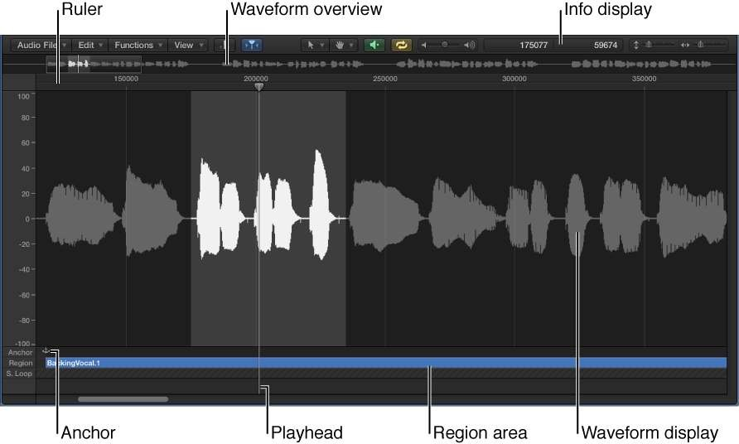

Previewing Audio:
Play back the imported audio files within the editing software to review their content and quality. Use headphones or speakers to ensure accurate playback.

Editing Audio (Optional):
If desired, use the editing tools within the software to make adjustments to the imported audio files. This could include trimming or cutting sections, adjusting volume levels, applying effects, or adding fades.

Saving Project:
After importing and editing audio to your satisfaction, save your project within the audio editing software to preserve your work. Use the appropriate file format and settings based on your intended use of the audio project.
Final Cut Pro
The user interface of Final Cut Pro is designed to streamline video editing, offering an intuitive layout with a focus on ease of navigation, flexibility, and customization. Here are the key elements:
1. Browser
- The Browser is where you organize and access all your media files, effects, and libraries. It’s located on the left side of the interface

2. Viewer
- The Viewer is located in the top right corner of the interface. This is where you preview your video, either from the timeline or from individual clips in the browser. The Viewer shows the real-time playback of your edit and allows for visual inspection of footage.
3. Canvas
- In Final Cut Pro X, the term "canvas" isn’t commonly used, but in older versions, it referred to the window where you would preview your timeline. In the current version, this function is covered by the Viewer, which lets you view the active timeline or selected media.
4. Timeline
- The Timeline is the central area of the interface where you place and arrange your video clips, audio, transitions, and effects to build your project.
5. Tools
- The Tools section is part of the Toolbar, typically located at the top of the interface. Here, you’ll find key editing tools like:
  - Select Tool (Arrow): Default tool for selecting and moving clips.
  - Blade Tool: For cutting clips into sections.
  - Zoom Tool: To zoom in and out of the timeline for detailed edits.
  - Trim Tool: For refining in and out points of clips.
  - Hand Tool: For dragging the timeline around without editing the clips.

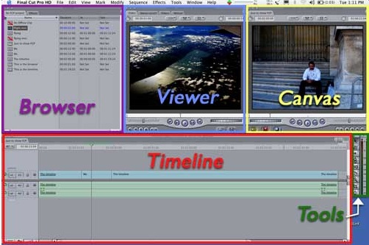

Working with Clips

Importing Media:

- Import media files into your project by dragging them into the browser or using the "Import Media" option.
- Supported media types include video clips, audio files, images, and graphics.

Organizing Clips:
- Organize your clips in the browser by creating events and keyword collections.
- Apply keywords and ratings to clips for easy searching and sorting.

Adding Clips to Timeline:
- Drag clips from the browser into the timeline to add them to your project.
- Use the overwrite and insert edit commands to add clips to specific locations in the timeline.

Trimming Clips:
- Trim the beginning and end of clips in the timeline using the selection tool (`A`) and the trim tool (`T`).
- Use the blade tool (`B`) to split clips into smaller segments.

Viewer:

Selecting Clips:
- Click on a clip in the timeline to select it.
- Double-click on a clip in the timeline to load it into the viewer for detailed editing.

Previewing Clips:
- Use the playhead to scrub through the clip in the viewer and preview its content.
- Press the spacebar to play/pause the clip.

Setting In and Out Points:
- Set in and out points to define a specific portion of the clip for editing.
- Use the `I` key to set the in point and the `O` key to set the out point.

Making Adjustments:
- Make adjustments to the selected clip using the controls in the viewer.
- Adjust parameters such as scale, position, rotation, and cropping.
Adding Effects:
- Apply effects and transformations to the selected clip using the inspector panel.
- Experiment with color correction, audio enhancements, and visual effects to enhance your clips.

Navigating Multiple Clips:
- Use the arrows in the viewer to navigate between multiple clips in the timeline.
VIDEO COMPRESSION METHODS
1.Spatial Compression (Intra-frame Compression)
Spatial compression compresses each frame of video individually by removing redundant information within the same frame. It's similar to image compression.
- Technique: Methods like JPEG compression are applied to each frame.
- Example: The video codec H.264 uses spatial compression to reduce redundancy within frames. It reduces file size without affecting the overall visual quality too much. However, it works on a frame-by-frame basis.
2.Temporal Compression (Inter-frame Compression)
Temporal compression reduces file size by eliminating redundant information across multiple frames. Instead of storing every frame, only the differences between frames (motion) are stored.
- Technique: The video is divided into:
  - I-Frames (Intra-coded frames): Fully self-contained images (keyframes).
  - P-Frames (Predicted frames): Contain only changes from the previous frame.
  - B-Frames (Bidirectional frames): Store differences between the previous and next frames.
- Example: Codecs like H.264 and H.265 (HEVC) use temporal compression heavily. Significant reduction in file size, especially in videos with slow-moving or static scenes.
3. Lossy Compression
This technique compresses video by discarding less important data that the human eye is unlikely to notice. Once this data is removed, it cannot be restored.
- Techniques:
  - Chroma Subsampling (4:2:0, 4:2:2): Reduces the resolution of color information since humans are more sensitive to luminance than chrominance.
- Codecs: H.264, H.265, VP9, and AV1 all use lossy compression.Highly reduced file sizes with minimal perceptible loss in quality, but artifacts may appear at very high compression levels.
4. Lossless Compression
This technique reduces video file size without any loss of data or quality. All original information can be perfectly restored when decompressed.
- Techniques:
  - Run-Length Encoding (RLE): Compresses repeating patterns of data.
  - Huffman Coding: A form of entropy encoding that uses shorter codes for more common data.
  - Lempel-Ziv-Welch (LZW): A dictionary-based encoding method.
- Codecs: Apple ProRes (lossless), H.264 (lossless mode), and FFV1.Preserves full video quality but with much larger file sizes than lossy compression.
5. Bitrate Control
- Variable Bitrate (VBR): Adjusts the bitrate according to the complexity of the scene. Higher bitrates are used for complex scenes (with lots of motion), and lower bitrates are used for simpler scenes. This provides better quality with lower file sizes.
- Constant Bitrate (CBR): Uses the same bitrate throughout the video. It ensures consistent file size but may compromise quality during complex scenes.
6. Entropy Coding
A method of encoding data using fewer bits for more frequent symbols. It is often combined with other compression techniques.
- Techniques:
  - Huffman Coding: As mentioned earlier, it assigns shorter codes to more frequent symbols.
  - Arithmetic Coding: Provides better compression efficiency by representing sequences of symbols as a single floating-point number.
- Example: Used in H.264 and H.265 codecs.
Audio compression techniques
Audio compression techniques are used to reduce the size of audio files while maintaining acceptable sound quality. There are two main types of audio compression: lossy and lossless. These techniques are crucial for efficient storage, streaming, and transmission of audio content.
1. Lossy Compression
Data is permanently removed from the audio file to reduce file size. Some audio quality is sacrificed, but the file becomes significantly smaller.
- How it works: It eliminates parts of the audio that are less noticeable to the human ear, such as very high or very low frequencies that are less perceptible.
2. Lossless Compression
Compresses audio without losing any data, preserving the original quality while reducing file size to a lesser extent compared to lossy methods.
- Examples: FLAC (Free Lossless Audio Codec), ALAC (Apple Lossless Audio Codec), WAV (when compressed), and APE (Monkey's Audio).
- Use Cases: Professional audio production, archiving, and high-quality music distribution.

3. Perceptual Coding
A key component of lossy compression, perceptual coding removes frequencies that are less audible to the human ear based on psychoacoustic models.
- Examples: Integral to MP3, AAC, and OGG Vorbis.
- Use Cases: Music streaming services where lower bitrates are required while maintaining perceived audio quality.
4. Entropy Coding
Further reduces file size using coding schemes like Huffman Coding and Arithmetic Coding to remove redundancy.
- Use Cases: Integral part of most audio codecs, typically as the final step after other compression stages.
5. Dynamic Range Compression (DRC)
Reduces the dynamic range of audio, making quieter sounds louder and louder sounds quieter, not to be confused with file size reduction.
- Use Cases: Broadcast audio, streaming, and applications where consistent audio levels are necessary.
6.Sub-band Coding
A type of compression where the audio spectrum is divided into sub-bands, and each sub-band is compressed separately.
Sub-band coding splits the audio signal into different frequency bands, and each band can be encoded with different levels of precision or bit rates based on its importance.
- Applications: This technique is common in formats like MP3 and AAC, where specific frequency bands (high or low frequencies) are compressed more heavily depending on psychoacoustic analysis.
Steps to Convert Video Files to Different Formats
1.Choose the Right Software or Tool
2.Install and Launch the Software
3.Import the Video File
4.Select the Output Format
5.Configure Codec and Quality Settings (Optional)
6.Select Output Destination
7.Start the Conversion Process
8.Review and Test the Converted File
9.Make Adjustments if Necessary
Turning clips into movie
- Step 1: Import Your Clips
- Open Final Cut Pro and create a new project by clicking File > New > Project.
- Import your media by clicking File > Import > Media, or drag your clips directly into the media browser.
- Step 2: Organize Your Media
- Organize your clips in the media browser by creating folders or bins to keep everything sorted.
- Step 3: Add Clips to the Timeline
1.Drag the clips from the media browser to the timeline in the order you want them to appear.
- Adjust the clip's length by dragging the edges of the clip in the timeline.
- Step 4: Edit and Arrange
- Trim Clips: Use the blade tool or trim tools to fine-tune your clips.
- Add Transitions: Insert transitions between clips for smoother flow.
- Step 5: Enhance Your Movie
- Add Effects: Explore filters and effects to enhance visuals.
- Include Audio: Import and adjust audio tracks as needed.
- Step 6: Export Your Movie
- Go to File > Share: Choose your desired export settings.
- Select Destination: Choose where to save or upload your movie.
Fix color and light issues in Final Cut Pro:
Step 1: Open the Color Inspector
- Select a Clip: Click on the clip in the timeline that you want to adjust.
- Open Color Inspector: Go to Window > Show in Workspace > Color Inspector or press Command + 6.
Step 2: Adjust Exposure
- Use the Exposure Controls: Adjust the Shadows, Midtones, and Highlights sliders to balance the light in your clip.
- Use the Histogram: Monitor the histogram to ensure you're not clipping highlights or losing detail in shadows.
Step 3: Correct Color
- Color Wheels: Use the Color Wheels to adjust the overall color balance:
  - Lift (Shadows): Adjust shadow tones.
  - Gamma (Midtones): Adjust mid-range tones.
  - Gain (Highlights): Adjust bright areas.
- Color Curves: Utilize the Color Curves tool for more precise adjustments:
  - Adjust the curve to modify specific color channels (Red, Green, Blue) or the overall luminance.
Step 4: Use Color Boards
- Color Board: Open the Color Board for more granular control over exposure, saturation, and color. Adjust the sliders to refine each aspect of your clip.
Step 5: Compare Before and After
- Toggle Bypass: Use the Compare button to toggle the effect on and off, helping you see the difference and make adjustments as needed.
Step 6: Final Adjustments
- Refine Your Edits: Make any final tweaks to ensure the colors and light match your vision for the project.

using transitions and titles in Final Cut Pro
Adding Transitions
Step 1: Open the Transitions Browser
- Access Transitions: Click on the Transitions button in the lower-right corner of the interface or go to Window > Go To > Transitions.
Step 2: Choose a Transition
- Browse Transitions: Scroll through the available transitions. You can preview them by hovering over each option.
Step 3: Apply a Transition
- Drag and Drop: Drag a transition effect to the cut between two clips in the timeline.
- Adjust Duration: Click on the transition in the timeline to adjust its duration by dragging its edges.
Step 4: Customize Transitions
- Select Transition: Click on the transition in the timeline.
- Open Inspector: Use the Inspector (Command + 4) to adjust specific parameters of the transition, such as duration or direction.
Adding Titles
Step 1: Open the Titles Browser
Access Titles: Click on the Titles button in the lower-right corner or go to Window > Go To > Titles.
Step 2: Choose a Title
Browse Titles: Explore the available title styles. Hover over to preview.
Step 3: Add a Title
Drag and Drop: Drag your selected title into the timeline where you want it to appear, typically above your clips.
Adjust Length: Resize the title in the timeline by dragging its edges.
Step 4: Review and Adjust
Preview Your Edits: Play through your timeline to see how transitions and titles look together.
Make Adjustments: Fine-tune timing and positioning as needed.
Step 5: Finalize
Once satisfied, continue with other editing tasks or proceed to export your project.

Working with audio

Importing Audio:
Import audio files into your project by dragging them directly into the browser or using the "Import Media" option.

Editing Audio:
Trimming: Trim audio clips by dragging the edges in the timeline or using shortcut keys.
Splitting: Split audio clips at specific points by positioning the playhead and using the blade tool (shortcut: B). Adjusting Levels: Use the audio meters to monitor levels and adjust volume levels using keyframes or the volume slider in the inspector.
Fading: Apply fade in/out effects to audio clips for smooth transitions using the fade handles or audio effects.

Enhancing Audio:
Equalization (EQ): Use EQ effects to adjust the frequency balance of audio clips, enhancing clarity or achieving specific tonal qualities.
Noise Reduction: Apply noise reduction effects to remove unwanted background noise or hum from audio recordings.
Compression: Use compression to control the dynamic range of audio, making quieter parts louder and louder parts quieter for a more balanced sound.
Panning: Adjust the stereo placement of audio clips using the pan control to create spatial effects.

Syncing Audio:
Use the "Synchronize Clips" feature to sync separately recorded audio with video clips automatically.

*****Refer the following topics on your Notebook*****
- Write about various video file formats supported by android phone.
- List the steps to convert video files to different formats.
- Enumerate the difficulties faced by editors with audio and video files.

